**Vaibhav Khullar**

**vaibhavkhullar55@gmail.com**

**“Be a Devops Pro”**

**Assignment 2**

**Assignment Part-3:**

1.

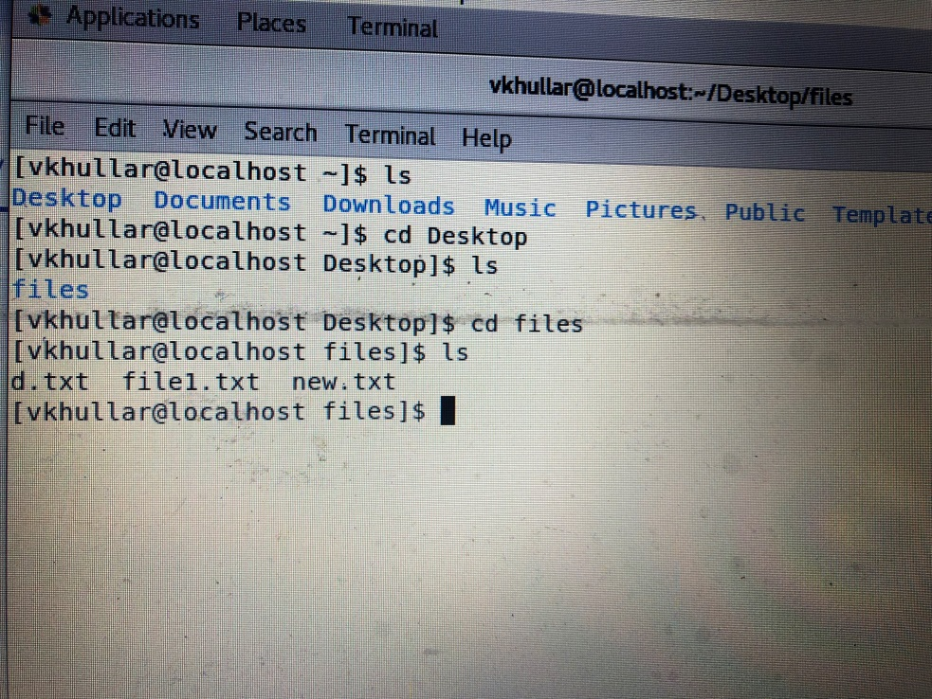

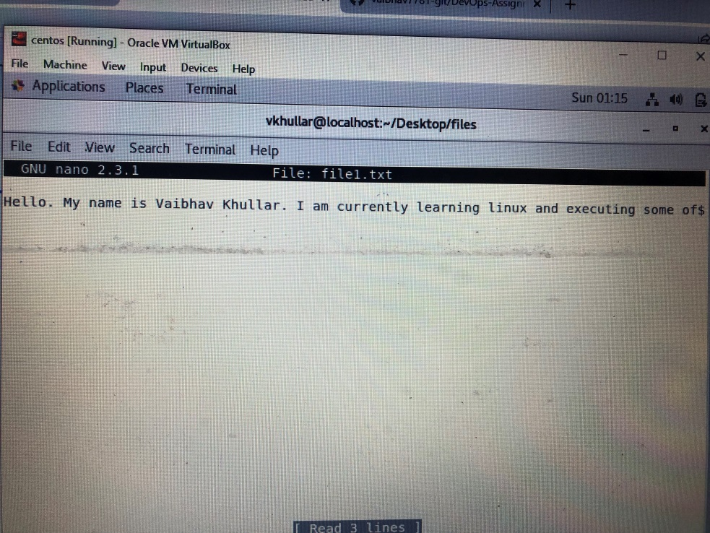

2.

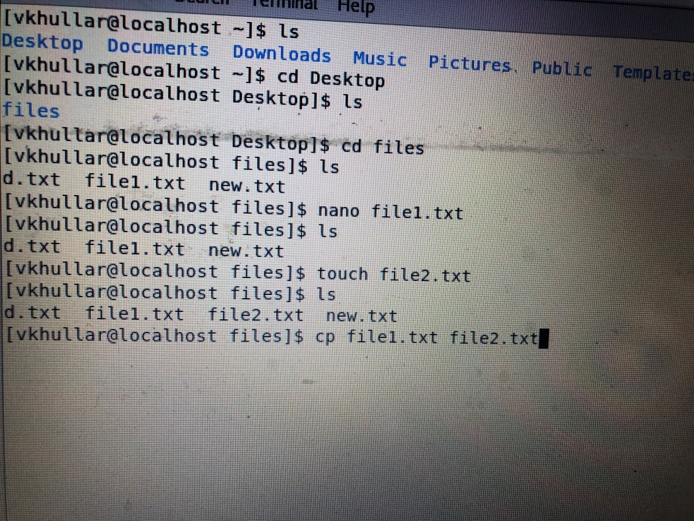

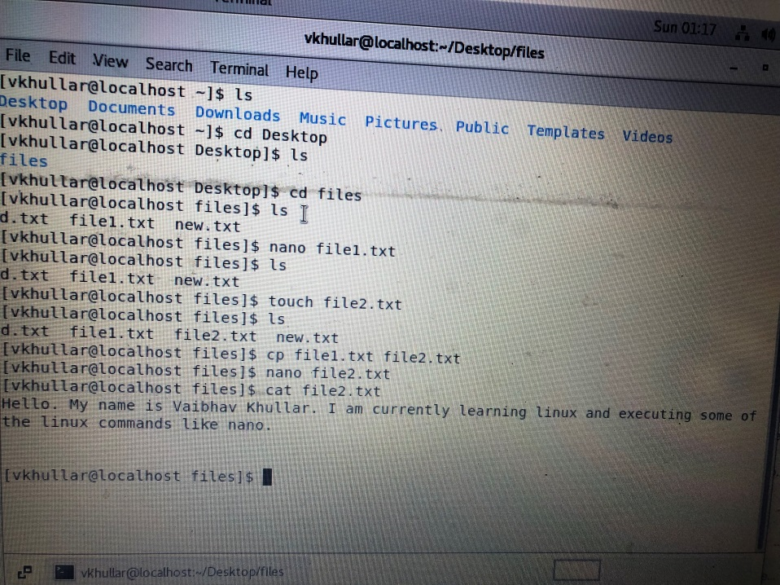

3.

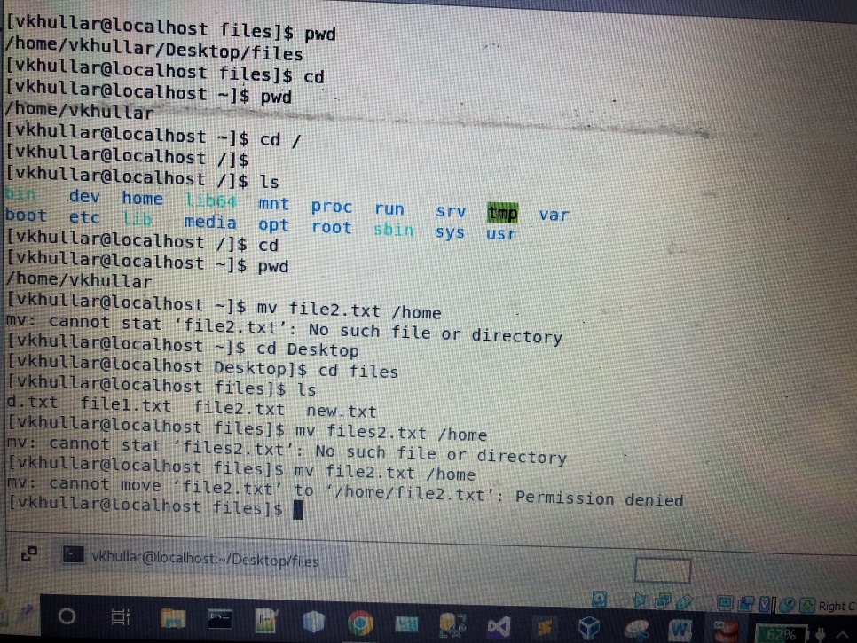

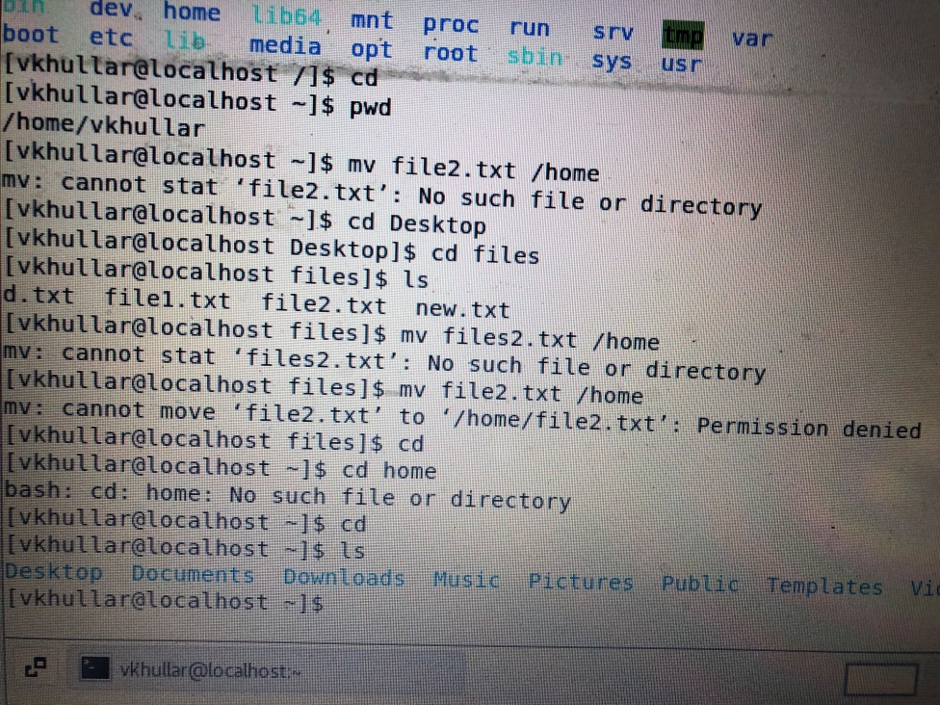

4.

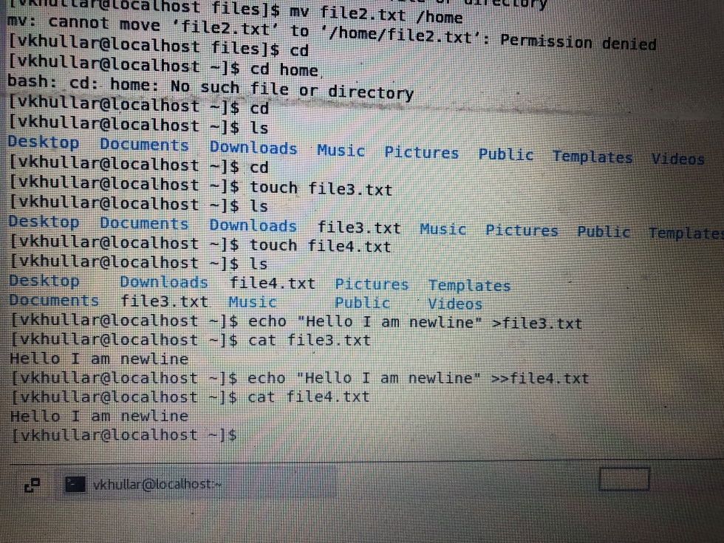

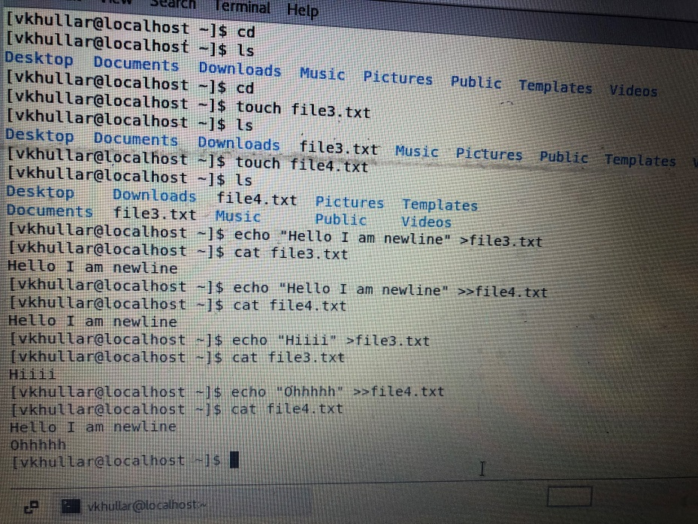

Difference between echo “Hello I am newline” >file3.txt and echo “Hello I am newline” >>file4.txt is that the former overwrites existing contents of file3.txt whereas the latter one just appends new contents with the older one present in file4.txt.

5.

